 Site Amendments

**Home Page**

Menu

Please change the word ‘Index’ to ’19 SHEEP’

Please make ‘19 SHEEP’ change colour with mouse over like the other menu items.

Please change Mood Logger to ‘My Moods’

Please change Dream Analysis to ‘My Dreams’

Please insert a ‘MY DASHBOARD’ menu item after My Dreams

Please insert a ‘MY DEVICES’ menu item after My dashboard

Please add ‘S’ to MY COMMITMENTS

Please change Messages to ‘My Messages’

Please insert an ‘ABOUT’ menu item after ‘MESSAGES’

Please insert an ‘INFORMATION PRIVACY’ menu item after ‘ABOUT’

Please insert an ‘ONE MILLION DREAMS PROJECT menu item after ‘INFORMATION PRIVACY’

For some reason I have white blocks where the menu items are.



Please delete the smart store heading icon in blue - it’s not working from a design perspective

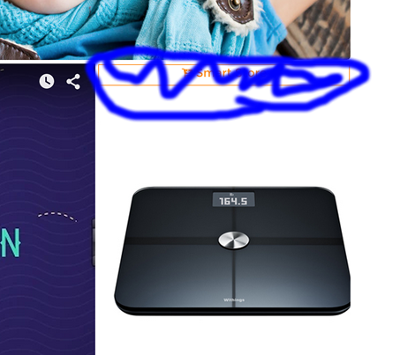

Sleep analyser form - this is nicely set up but when you submit there is no page that acknowledges that you have completed the survey or what will happen next.

Please make the words ‘LOGIN’ and ‘SIGNUP’ in capitals

Signup Page

For some reason the facebook login and the google login are not displaying.

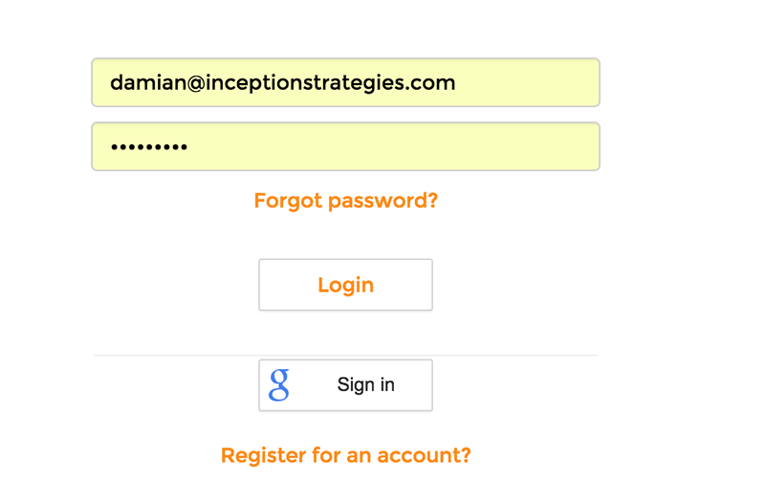

Sign Up

Sign up presently does not allow for the input of decimal values for height and weight.

For height it wanted either 1 or 2 metres

For weight it woudn’t accept 83.5 Kg

Present Dashboard

My activity score seems to be working but not my sleep score.

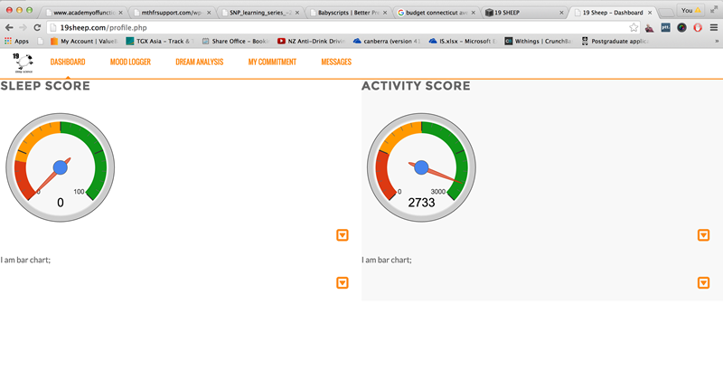

Please adjust as follows

Please remove the summary header text under both the gauges.

Please change the response results text to the font (Abadi Sans MT Condensed Light) and to the correct size as per the rest of the text in the site.

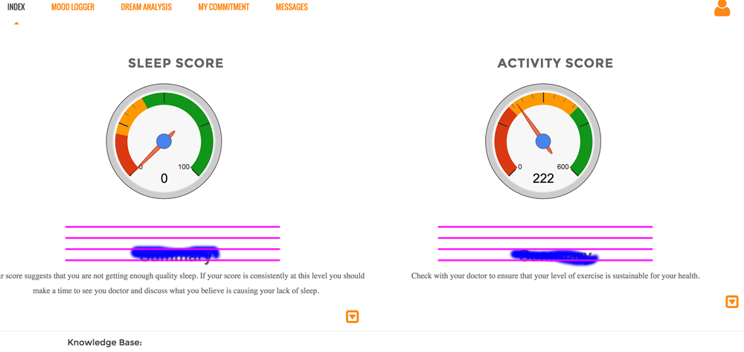

My activity score is changing each day but the message is not and seems stuck on a message that is designed for someone over the age of 60.

The activity bar graphs are working well. But they look messy and have a big grey shadow underneath them. They are also too thick and do not need the black vertical line on the LHS.

We will need to include a key for the activity bar graph so people understand what the different colors mean.

The title fonts ‘Sat’ Sunday’ ‘today’ - I am in an American timezone so today is ‘Sunday’ as I write this but it is stuck in Australian timezone and saying that it is Monday so we may need to ask the user which timezone they are in during the setup or add device phase.

Activity drilldown graph was supposed to be an intensity graph not more gauges.

Bar graph summaries on both pages seem to be working so that is good.

**Dream form**

Please remove the reset button.

Please add a check box next to the submit button - I would like 19 sheep to assist me interpreting this dream. Add another button ‘Log another dream’.

